KEYBOARD LAB GUIDE

Purpose of this LAB is to create a USB HID CLASS project that make the board act as a keyboard .
-make the board get recognized as keyboard in device manager
-This project will make the blue button print a certain character in the screen
1-First of all open your cubeIDE and create a new STM32 Project
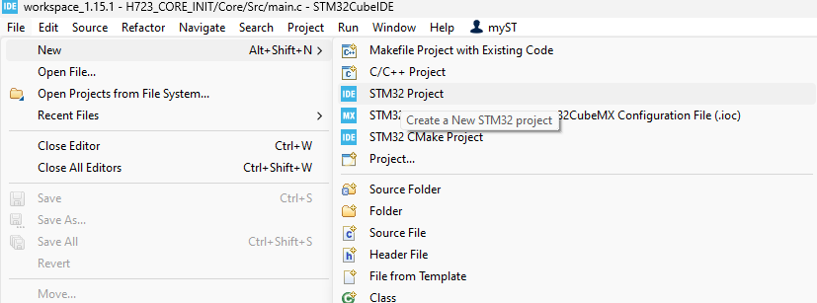
2-Choose your board : in this lab I have a h723ZG NUCLEO
Press next /Name your project
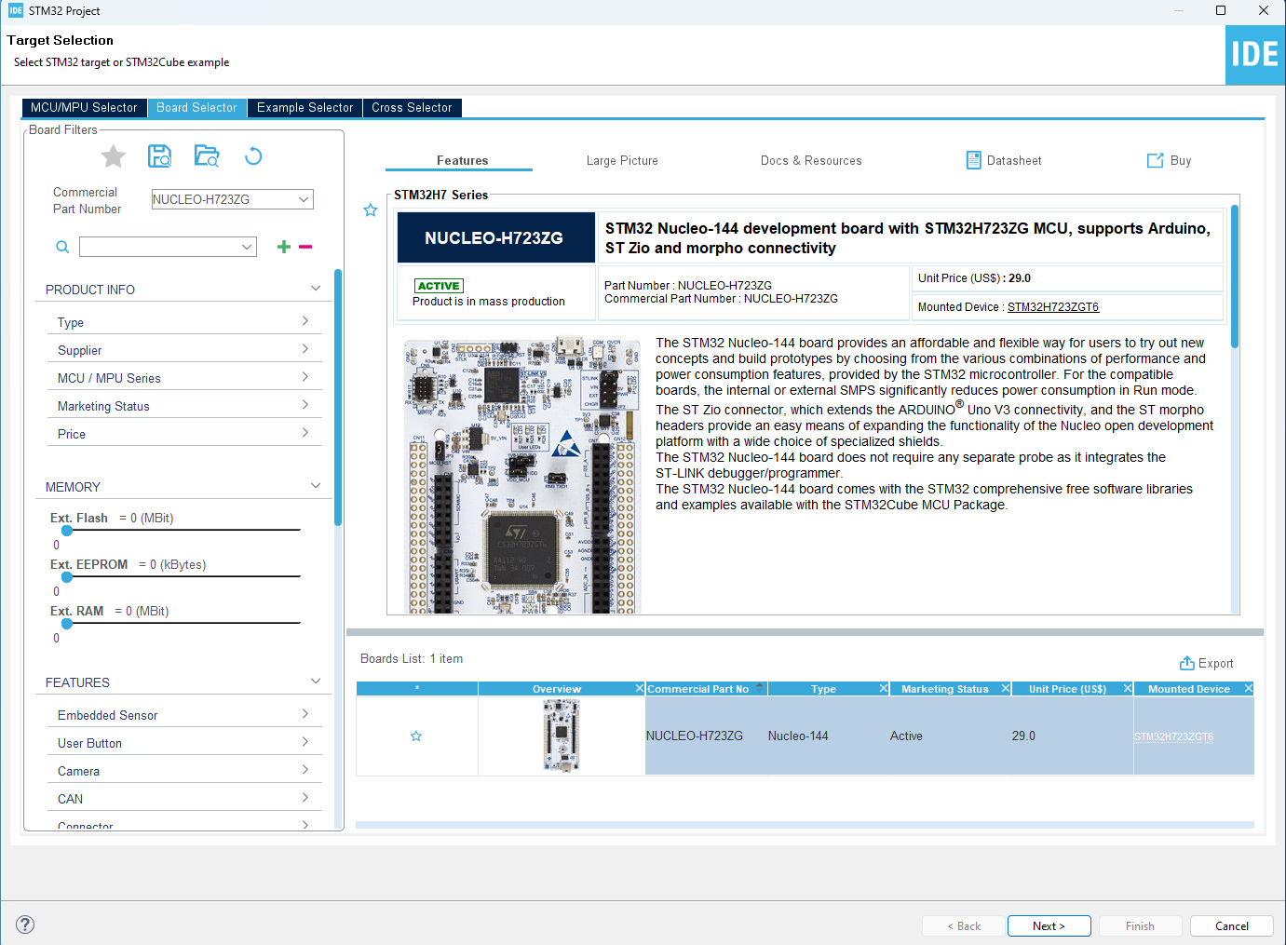
3-When the .ioc file open . Press pinout /clear pinouts
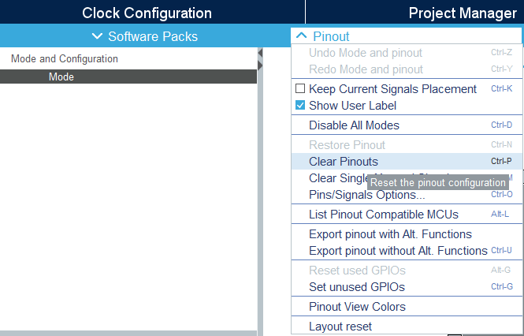
4-In categories Press connectivity USB/OTG_HS
And in internal FS PHY choose Device only
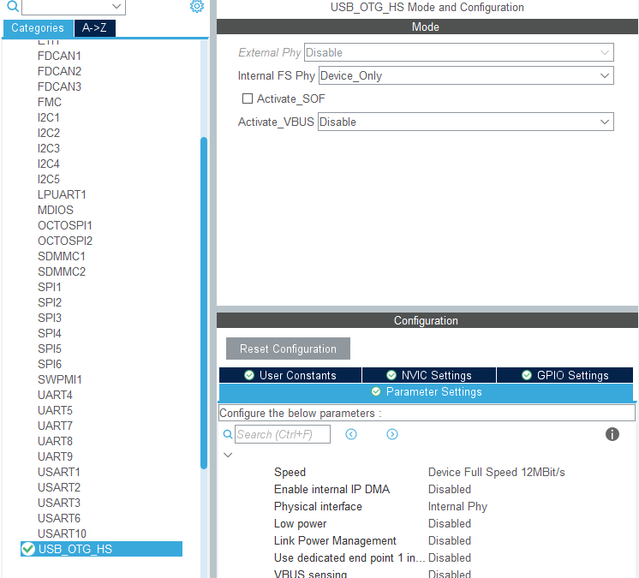

5-In middleware and software packs click USB device and chose HID class
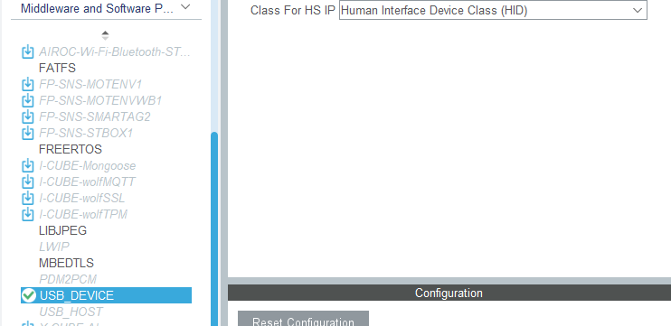
6-Finally search for the blue button pin and put it as GPIO_EXTI:
NB :In most boards user button is attached to the pc13 pin but please check necessary document to verify
GO TO system core GPIO NVIC and enable global interrupt
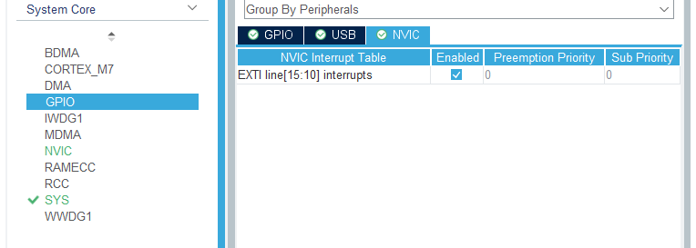
7-Then generate the code
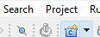

8-Open device_hid.h and change HID_mouse_report_desc_size to 63u
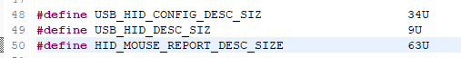
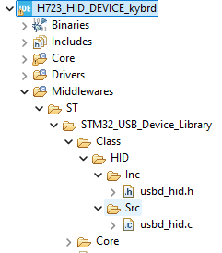
9-Then open device_hid.c and change the ninterfaceprotocol to 0x01 in descriptor of joystick mouse interface in
“ALIGN_BEGIN static uint8_t USBD_HID_CfgDesc[USB_HID_CONFIG_DESC_SIZ] __ALIGN_END =”
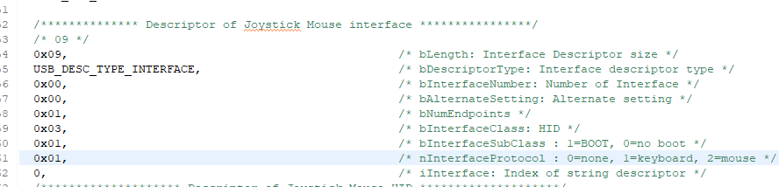
10-Then change the content of : __ALIGN_BEGIN static uint8_t HID_MOUSE_ReportDesc[HID_MOUSE_REPORT_DESC_SIZE] __ALIGN_END =
With keyboards descriptor
0x05, 0x01, // USAGE_PAGE (Generic Desktop)
0x09, 0x06, // USAGE (Keyboard)
0xa1, 0x01, // COLLECTION (Application)
0x05, 0x07, // USAGE_PAGE (Keyboard)
0x19, 0xe0, // USAGE_MINIMUM (Keyboard LeftControl)
0x29, 0xe7, // USAGE_MAXIMUM (Keyboard Right GUI)
0x15, 0x00, // LOGICAL_MINIMUM (0)
0x25, 0x01, // LOGICAL_MAXIMUM (1)
0x75, 0x01, // REPORT_SIZE (1)
0x95, 0x08, // REPORT_COUNT (8)
0x81, 0x02, // INPUT (Data,Var,Abs)
0x95, 0x01, // REPORT_COUNT (1)
0x75, 0x08, // REPORT_SIZE (8)
0x81, 0x03, // INPUT (Cnst,Var,Abs)
0x95, 0x05, // REPORT_COUNT (5)
0x75, 0x01, // REPORT_SIZE (1)
0x05, 0x08, // USAGE_PAGE (LEDs)
0x19, 0x01, // USAGE_MINIMUM (Num Lock)
0x29, 0x05, // USAGE_MAXIMUM (Kana)
0x91, 0x02, // OUTPUT (Data,Var,Abs)
0x95, 0x01, // REPORT_COUNT (1)
0x75, 0x03, // REPORT_SIZE (3)
0x91, 0x03, // OUTPUT (Cnst,Var,Abs)
0x95, 0x06, // REPORT_COUNT (6)
0x75, 0x08, // REPORT_SIZE (8)
0x15, 0x00, // LOGICAL_MINIMUM (0)
0x25, 0x65, // LOGICAL_MAXIMUM (101)
0x05, 0x07, // USAGE_PAGE (Keyboard)
0x19, 0x00, // USAGE_MINIMUM (Reserved)
0x29, 0x65, // USAGE_MAXIMUM (Keyboard Application)
0x81, 0x00, // INPUT (Data,Ary,Abs)
0xc0 // END_COLLECTION

11-Then go to the main.c and declare this typedef structure in private variables part to store the keys values
/* USER CODE BEGIN PV */
typedef struct
{
uint8_t MODIFIER;
uint8_t RESERVED;
uint8_t KEYCODE1;
uint8_t KEYCODE2;
uint8_t KEYCODE3;
uint8_t KEYCODE4;
uint8_t KEYCODE5;
uint8_t KEYCODE6;
} keyboardHID;

keyboardHID keyboardhid = {0,0,0,0,0,0,0,0};

/* USER CODE END PV */

12-And call this variable in private defines :
* Private define ------------------------------------------------------------*/
/* USER CODE BEGIN PD */
extern USBD_HandleTypeDef hUsbDeviceHS;

/* USER CODE END PD */

13-Then go to the while loop in int main void and use this code to make the press of the button able to control printing the variables that will be stored in the structure that we declares above and send it using the send report function .
while (1)
{
/* USER CODE END WHILE */

/* USER CODE BEGIN 3 */
if (HAL_GPIO_ReadPin(GPIOC, GPIO_PIN_13) == GPIO_PIN_SET)
{
keyboardhid.MODIFIER = 0x00; //
keyboardhid.KEYCODE1 = 0x4E; // press 'pagedown button '
keyboardhid.KEYCODE2 = 0x05; // press 'b'
USBD_HID_SendReport(&hUsbDeviceHS, &keyboardhid, sizeof (keyboardhid));
HAL_Delay (500);
}
else
{
keyboardhid.MODIFIER = 0x00; //
b keyboardhid.KEYCODE1 = 0x00; // release key
keyboardhid.KEYCODE2 = 0x00; // release key
USBD_HID_SendReport(&hUsbDeviceHS, &keyboardhid, sizeof (keyboardhid));
HAL_Delay (1000); }
/* USER CODE END 3 */
}
}

14-In case you want to get rid off the blue button condition and make the board print automatically the letters since you start running your project you just need to remove the button condition
while (1)
{
/* USER CODE END WHILE */

/* USER CODE BEGIN 3 */

keyboardhid.MODIFIER = 0x00; //
keyboardhid.KEYCODE1 = 0x4E; // press 'pagedownbutton'
keyboardhid.KEYCODE2 = 0x05; // press 'b'
USBD_HID_SendReport(&hUsbDeviceHS, &keyboardhid, sizeof (keyboardhid));
HAL_Delay (500);

keyboardhid.MODIFIER = 0x00; // shift release
keyboardhid.KEYCODE1 = 0x00; // release key
keyboardhid.KEYCODE2 = 0x00; // release key
USBD_HID_SendReport(&hUsbDeviceHS, &keyboardhid, sizeof (keyboardhid));
HAL_Delay (1000); }
/* USER CODE END 3 */

}

** this code will print AB automatically when blue button is pressed if you want to chose other keys just replace the AB values with the key corresponding value wanted(for example pagedown 0x4E and pageup is 0x4B) here is a table with the key corresponding value
Key | Value | Key | Value | Key | Value | Key | Value
A | 0x04 | B | 0x05 | C | 0x06 | D | 0x07
E | 0x08 | F | 0x09 | G | 0x0A | H | 0x0B
I | 0x0C | J | 0x0D | K | 0x0E | L | 0x0F
M | 0x10 | N | 0x11 | O | 0x12 | P | 0x13
Q | 0x14 | R | 0x15 | S | 0x16 | T | 0x17
U | 0x18 | V | 0x19 | W | 0x1A | X | 0x1B
Y | 0x1C | Z | 0x1D | 1 | 0x1E | 2 | 0x1F
3 | 0x20 | 4 | 0x21 | 5 | 0x22 | 6 | 0x23
7 | 0x24 | 8 | 0x25 | 9 | 0x26 | 0 | 0x27
Enter | 0x28 | Escape | 0x29 | Backspace | 0x2A | Tab | 0x2B
Space | 0x2C | Minus | 0x2D | Equal | 0x2E | Left Bracket | 0x2F
Right Bracket | 0x30 | Backslash | 0x31 | Non-US # and ~ | 0x32 | Semicolon | 0x33
Apostrophe | 0x34 | Grave Accent | 0x35 | Comma | 0x36 | Period | 0x37

15-Now just build and debug your project
When you press the resume button , the board should automatically print the selected key in every place where you put your cursor when you press the Blue button if configured or automatically if you didn’t include the blue button
